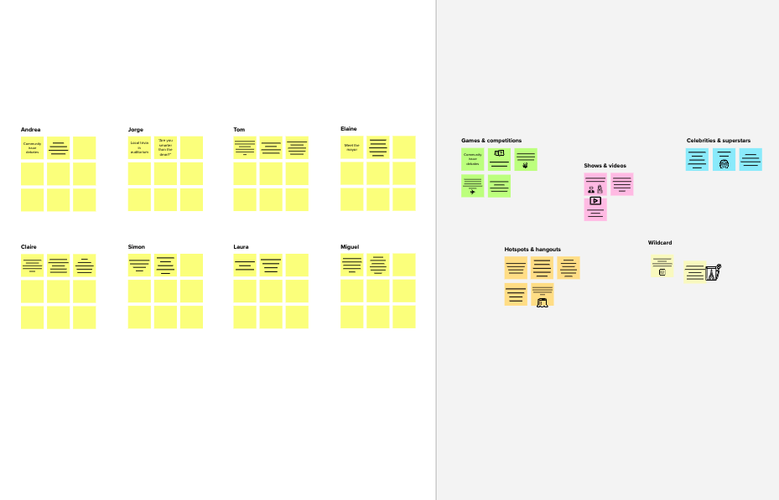

# Brainstorm

**TIP**

You can select a sticky note and hit the pencil [switch to sketch] icon to start drawing!

## Before you collaborate

A little bit of preparation goes a long way with this session. Here’s what you need to do to get going.

10 minutes

**1**

## Define your problem statement

What problem are you trying to solve? Frame your problem as a How Might We statement. This will be the focus of your brainstorm.

5 minutes

**2**

## Brainstorm

Write down any ideas that come to mind that address your problem statement.

10 minutes

**3**

## Group ideas

Take turns sharing your ideas while clustering similar or related notes as you go. Once all sticky notes have been grouped, give each cluster a sentence-like label. If a cluster is bigger than six sticky notes, try and see if you and break it up into smaller sub-groups.

20 minutes

**4**

## Prioritize

Your team should all be on the same page about what's important moving forward. Place your ideas on this grid to determine which ideas are important and which are feasible.

**20 minutes**

## After you collaborate

You can export the mural as an image or pdf to share with members of your company who might find it helpful.

**Quick add-ons**

# & idea prioritization

**PROBLEM**

How to help the user to track the monthly expenses and send alerts to the user about spending expenses

### Use this template in your own brainstorming sessions so your team can unleash their imagination and start shaping concepts even if you're

1. Team gathering

Define who should participate in the session and send an invite. Share relevant information or pre-work ahead.

1. Set the goal

Think about the problem you'll be focusing on solving in the brainstorming session.

ANSU K SAM

Limitations for budget

To user to enter the spending

Keep accurate records

Edit income and expenses

Add remainder and get notify

**CHANDRU S**

Set smart budget to help you not over spend money in a choosen category

Create a additional steam of income

Get monthly report as pdf or excel sheet

Add multiple stream of

To user to enter the spending

**TIP**

Add customizable tags to sticky notes to make it easier to find, browse, organize, and categorize important ideas as themes within your mural.

Set Budget

Keep accurate records

##### Category 1 Category 2

Set Budget

Set smart budget to help you not over spend money in a choosen

category

Create a additional steam of income

Add multiple stream of income

1. Share the mural

**Share a view link** to the mural with stakeholders to keep them in the loop about the outcomes of the session.

1. Export the mural

Export a copy of the mural as a PNG or PDF to attach to emails, include in slides, or save in your drive.

Set smart budget to help you not over spend money in a choosen catagory

### not sitting in the same room.

**10 minutes** to prepare

**1 hour** to collaborate

**2-8 people** recommended

1. Learn how to use the facilitation tools

Use the Facilitation Superpowers to run a happy and productive session.

[Open article](https://support.mural.co/en/articles/2113740-facilitation-superpowers)

Add income and expenses

**DINESH KUMAR E**

Generate Monthly report

Filter the expenses periodically

Helps you to stick on your budget and cut out impulse spending

income

Limitations for budget

Categorize the expenses

To remind user to enter the spendings

#### Keep moving forward

Strategy blueprint

Define the components of a new idea or

#### Key rules of brainstorming

To run an smooth and productive session

Edit user profile

###### AURNO SHYRIN

Add multiple stream of income

To remind

Categorize

Category 3

Category 4

strategy.

[Open the template](https://app.mural.co/template/e95f612a-f72a-4772-bc48-545aaa04e0c9/984865a6-0a96-4472-a48d-47639307b3ca)

Bug Free

UI

Categorize the expenses

Generate Monthly report

Add income and expenses

**Customer experience journey map**

Understand customer needs, motivations, and

Stay in topic. Defer judgment.

Encourage wild ideas. Listen to others.

Navigate to dash board

Set Budget

user to enter the spendings

the expenses

No need for

Add remainder and get

History of Transactions

Generate Monthly report

Keep accurate records

obstacles for an experience.

[Open the template](https://app.mural.co/template/b7114010-3a67-4d63-a51d-6f2cedc9633f/c1b465ab-57af-4624-8faf-ebb312edc0eb)

Add remainder and get notify

Go for volume. If possible, be visual.

Filter the expenses periodically

Visualize the expense

Show cash flow

Generate monthly record

Feedback System

Overspending / underspending of money

complicated Excel sheets

notify

Helps you to stick on your budget and cut out impulse spending

Show cash flow

Feedback System

Visualize the expense

Helps you to stick on your budget and cut out impulse spending

Navigate to dash board

Strengths, weaknesses, opportunities & threats

Identify strengths, weaknesses, opportunities, and threats (SWOT) to develop a plan.

|  |  |
| --- | --- |
|  |  |
|  |  |

[**Open the template**](https://app.mural.co/template/6a062671-89ee-4b76-9409-2603d8b098be/ca270343-1d54-4952-9d8c-fbc303ffd0f2)

#### Importance

If each of these tasks could get done without any difficulty or cost, which would have the most positive impact?

**TIP**

Participants can use their cursors to point at where sticky notes should go on the grid. The facilitator can confirm the spot by using the laser pointer holding the **H key** on the keyboard.

[Share template feedback](https://muralco.typeform.com/to/CiqaHVat?typeform-source=app.mural.co)

[**Share template feedback**](https://muralco.typeform.com/to/CiqaHVat?typeform-source=app.mural.co)

#### Feasibility

Regardless of their importance, which tasks are more feasible than others? (Cost, time, effort, complexity, etc.)

**Template**

###### Need some inspiration?

See a finished version of this template to kickstart your work.

[**Open example**](https://app.mural.co/template/e5a93b7b-49f2-48c9-afd7-a635d860eba6/93f1b98d-b2d2-4695-8e85-7e9c0d2fd9b9)